|  |  |
| --- | --- |
| Date | 17 November 2022 |
| Team ID | PNT2022TMID10557 |
| Project Name | AI-Powered Nutrition Analyzer for Fitness Enthusiasts |

1. Home.html

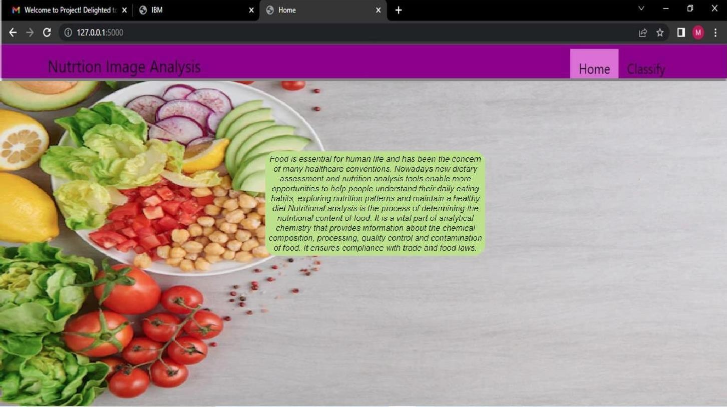

PNT2022TMID10557

1. Image.html

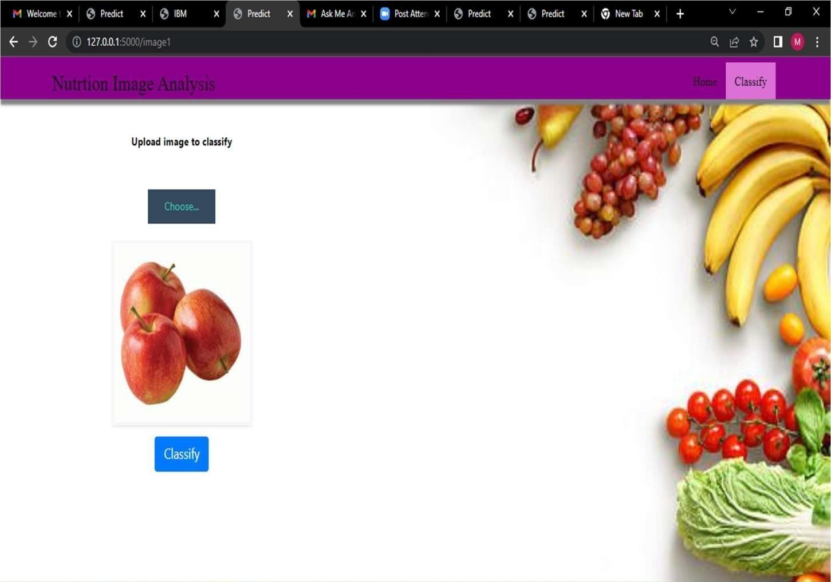

PNT2022TMID10577

1. Imageprediction.html

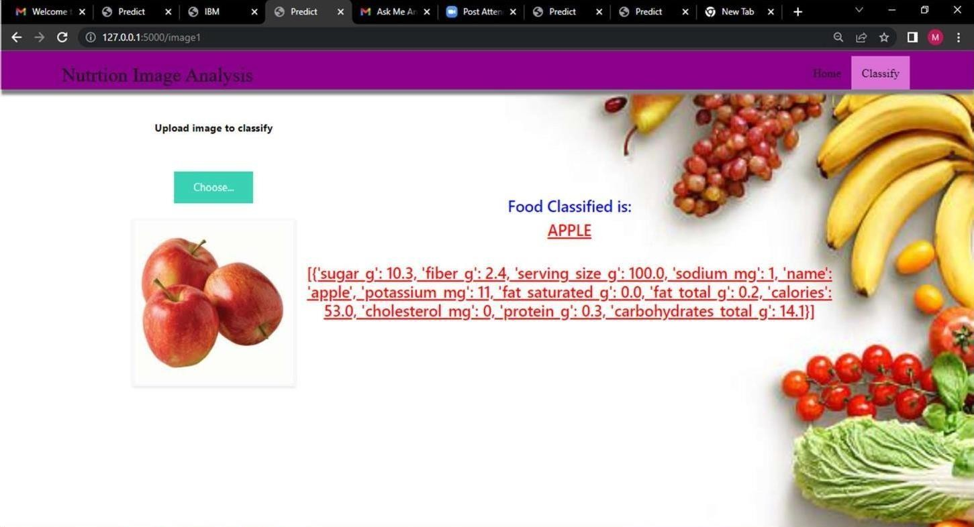

PNT2022TMID10557

1. Other food classification samples

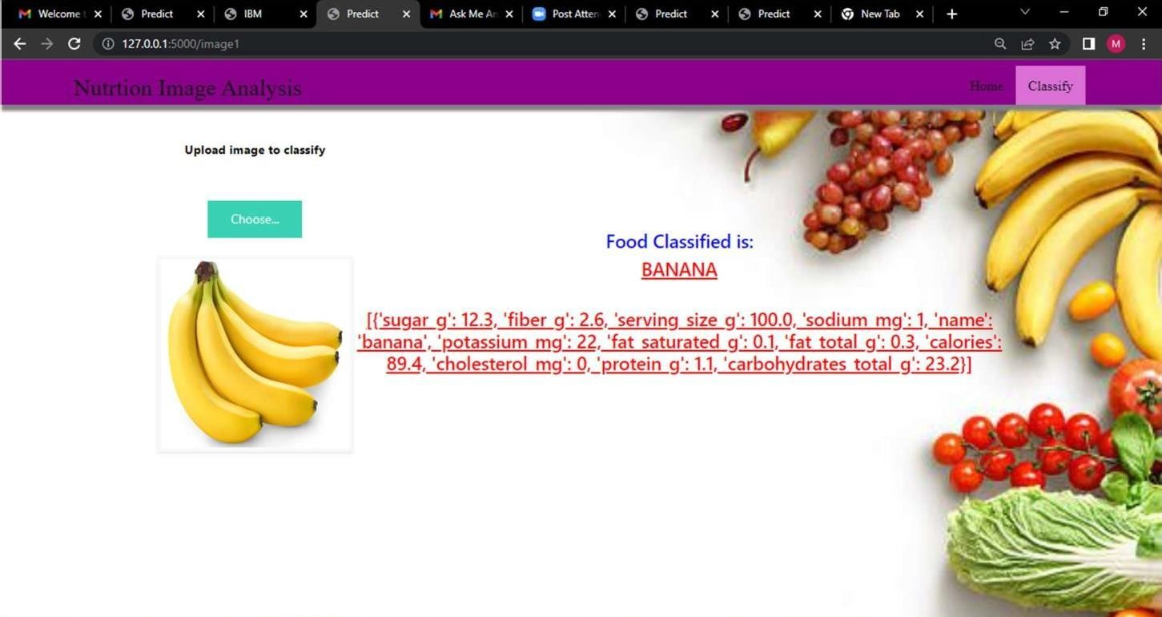

PNT2022TMID10557

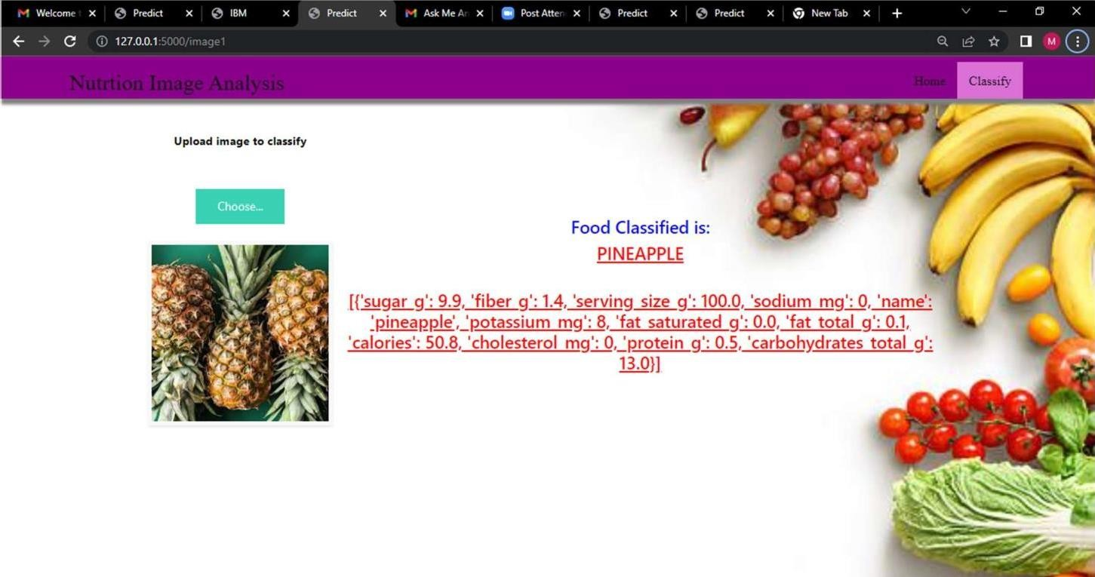

PNT2022TMID10557